Database Management System LAB Spring Semester 2024-25

Lab Assignment 3
Name – Soham Chakraborty Roll No – 22CS02002

Ans – 1) Foreign keys are to be added later on in the tables.
Note that in all the tables below Initial order is not the same as in Assignment because of addition of Primary Keys, the rows are by DEFAULT sorted in order of PRIMARY KEY.
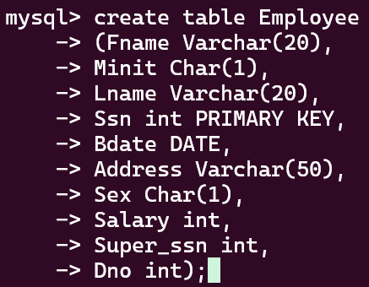
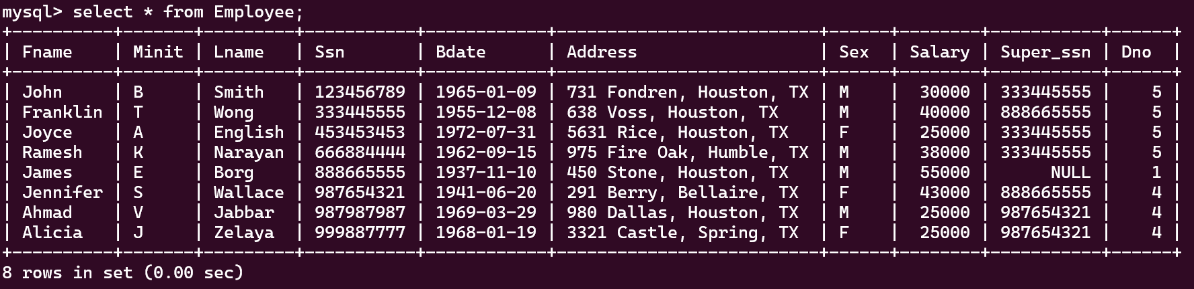
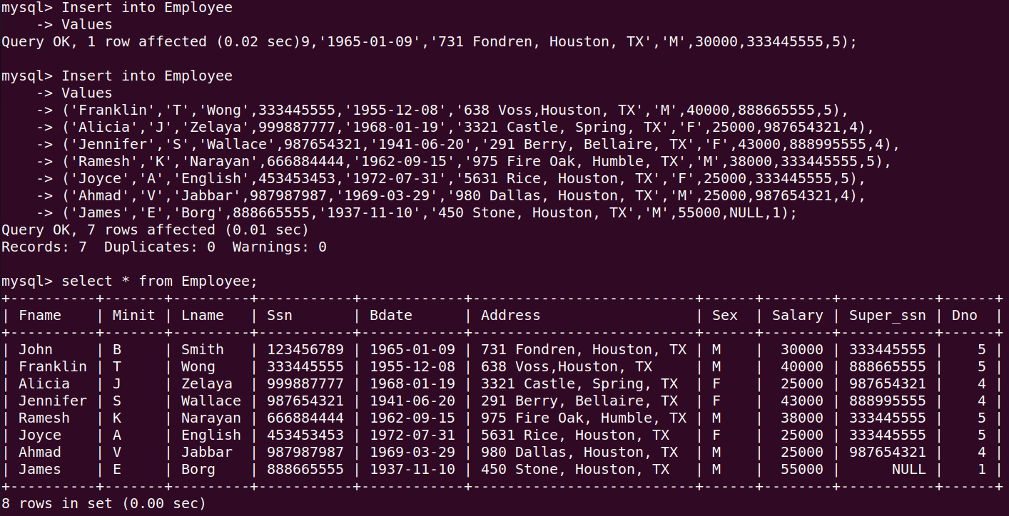

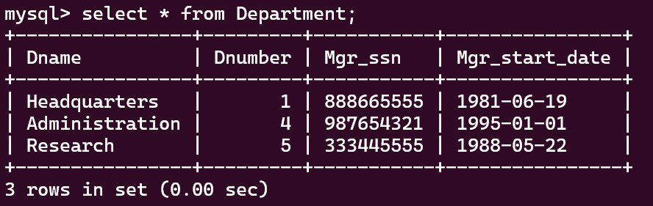
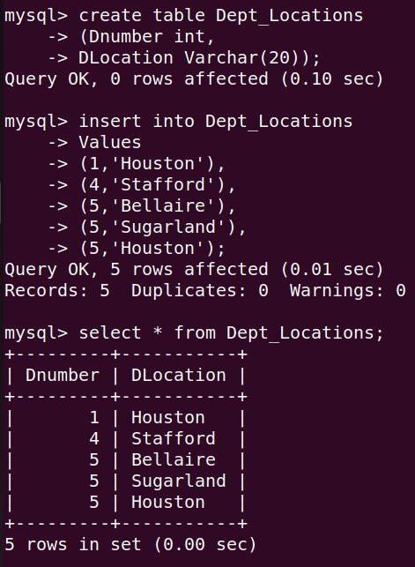
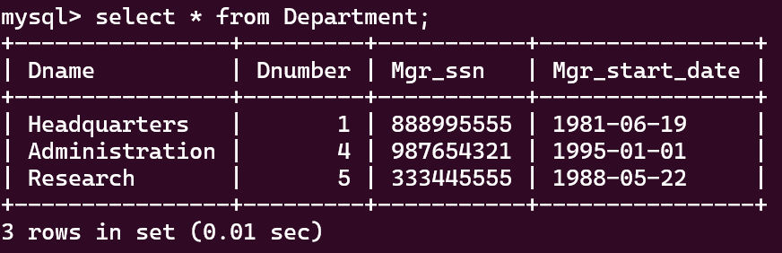
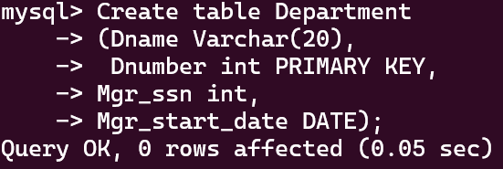
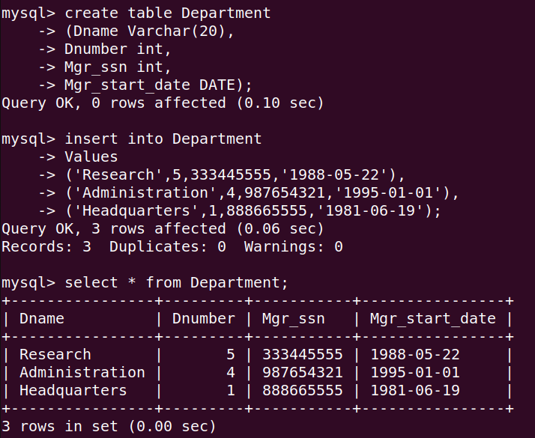

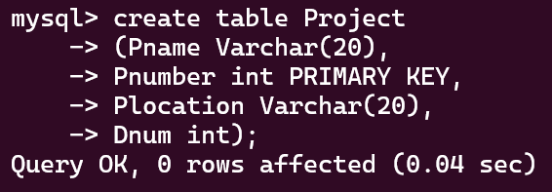
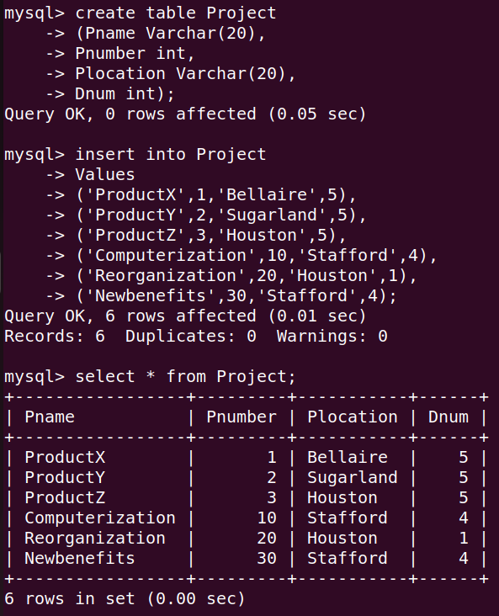

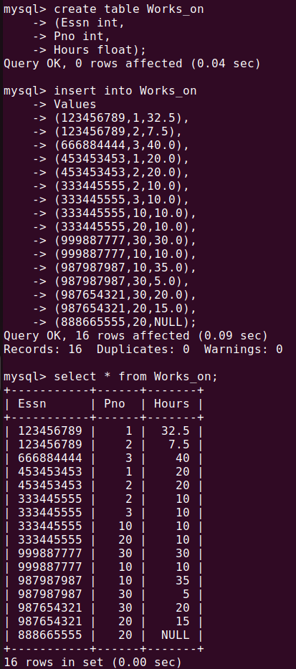

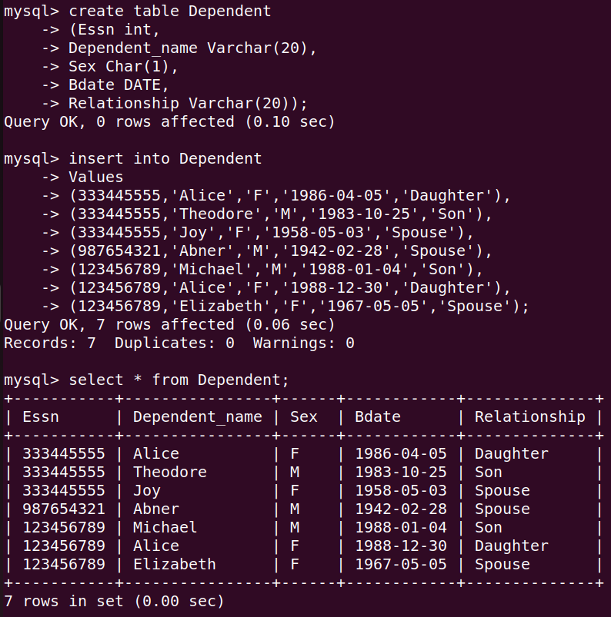

Adding Foreign Keys

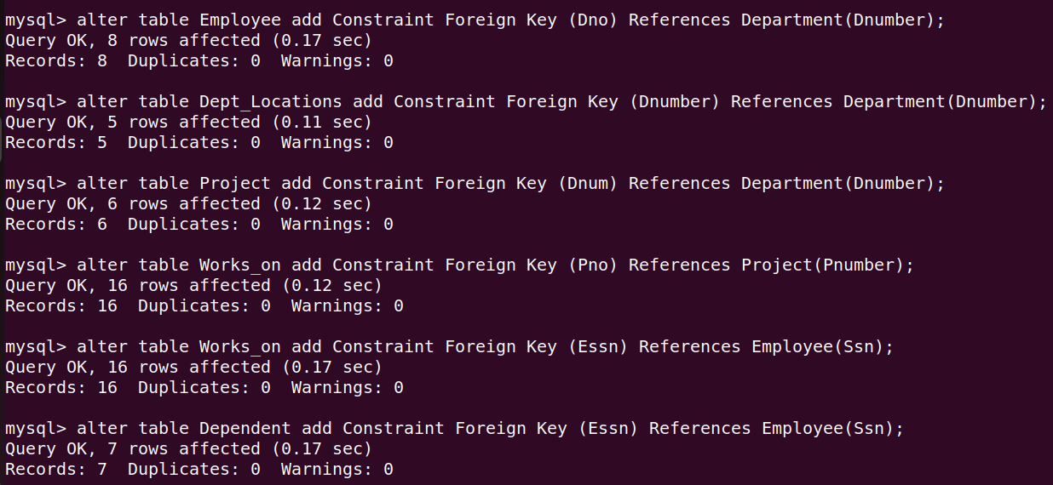

a)

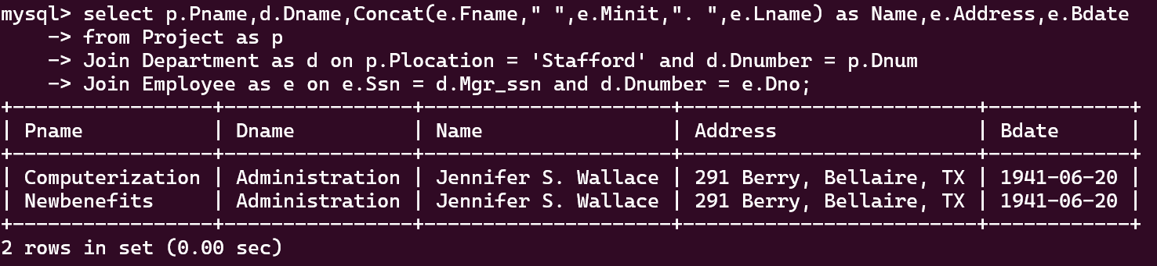

b)
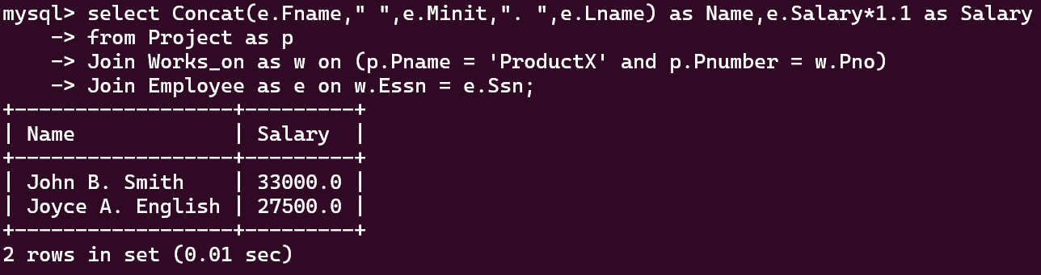

c)
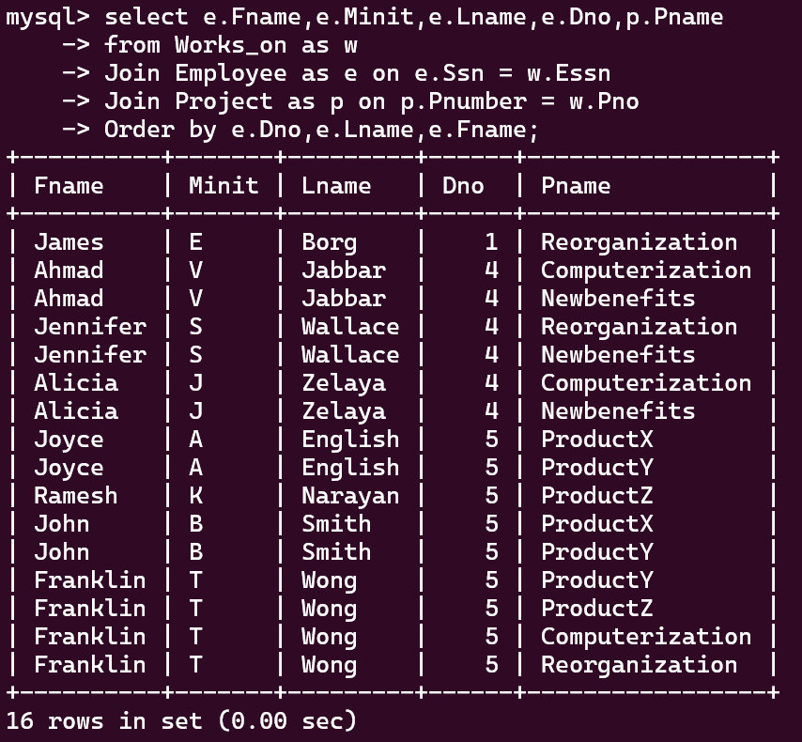

d)

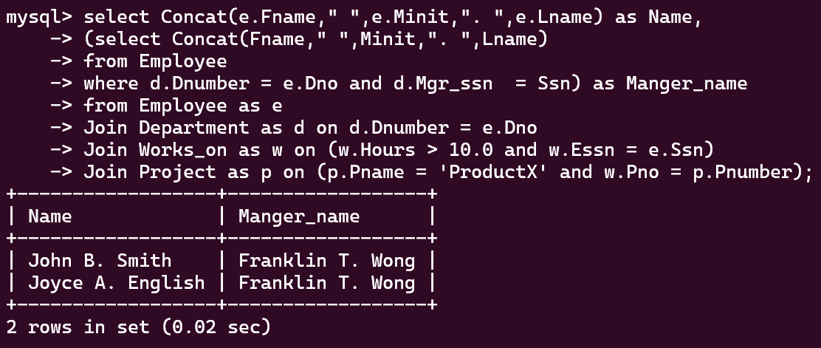

e) Note that there Smith himself will always be included in the list since he is compared to himself. If required Smith can be left out by putting a check condition in the where clause
Essn != 123456789
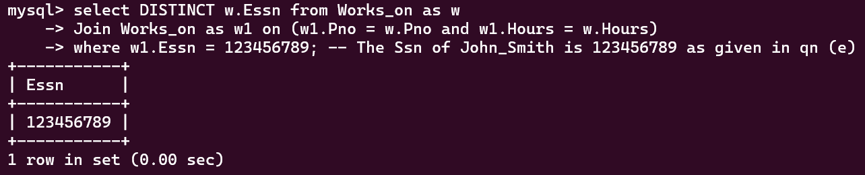

f)
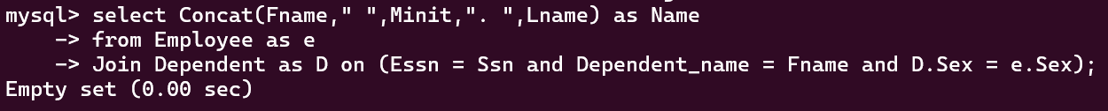

g)
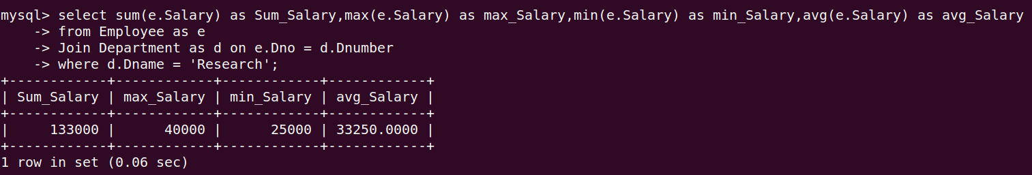

h)
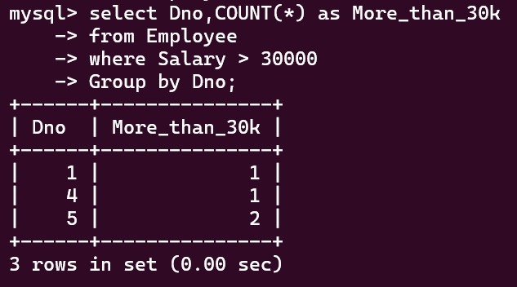

i)
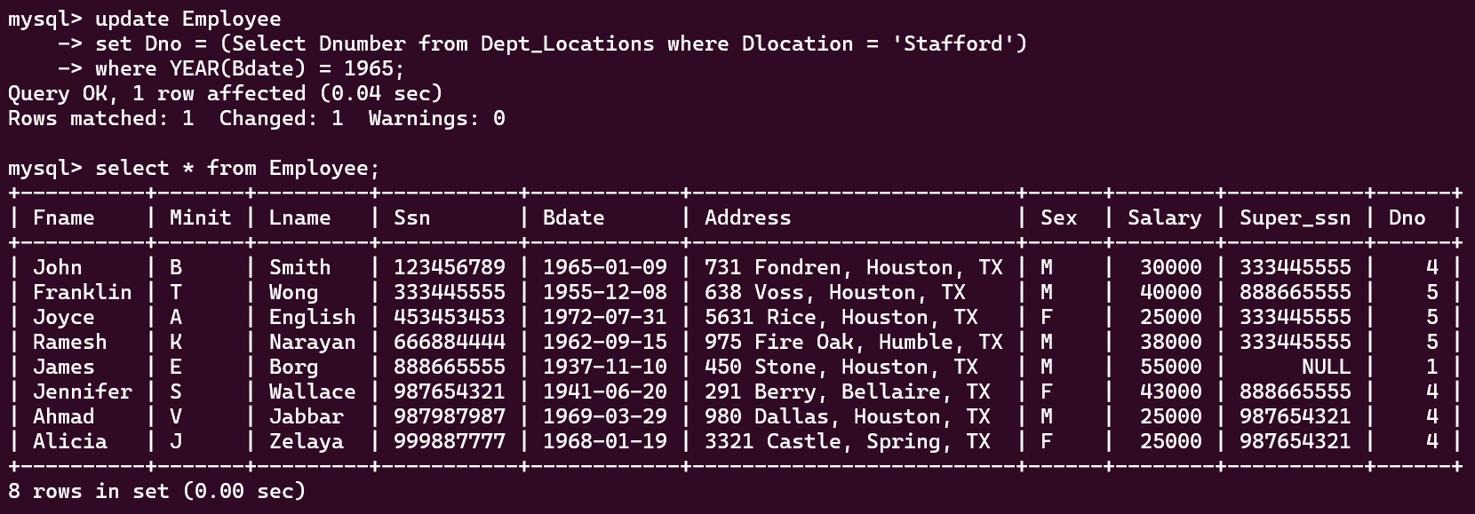

j) Similar to (e) note that Smith himself will always be included in the list and if required he can be excluded by putting a where clause “ Lname != Smith ” .
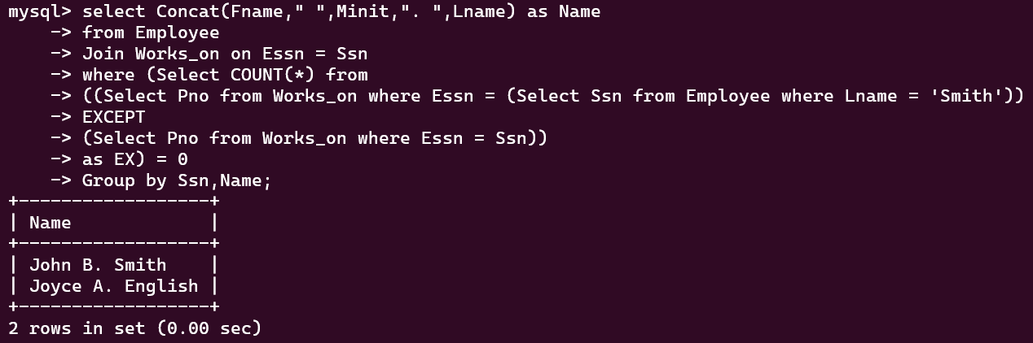

k)
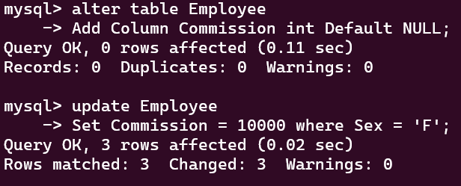

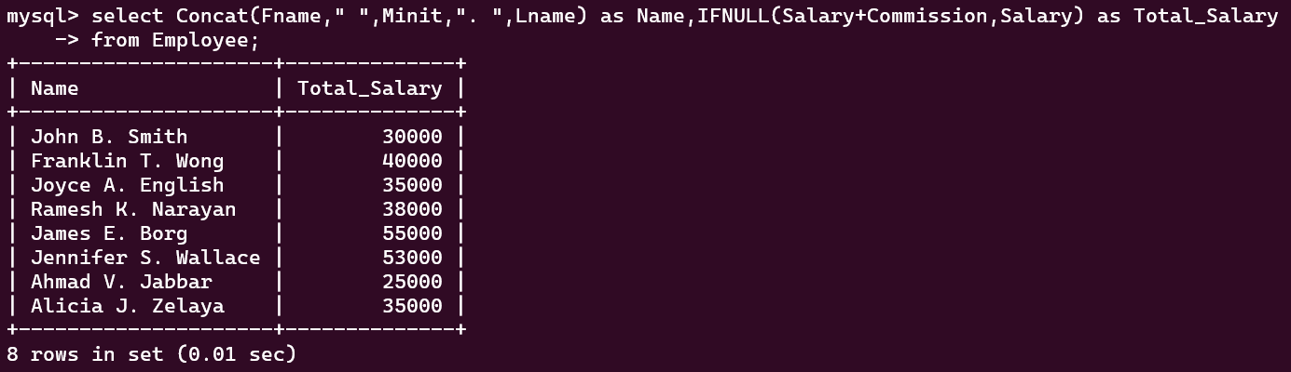

l) First we have to ensure the Foreign Key supports – ON DELETE CASCADE.
Since in the initial declaration of foreign key, ON DELETE CASCADE was not added we are going to add it manually now.
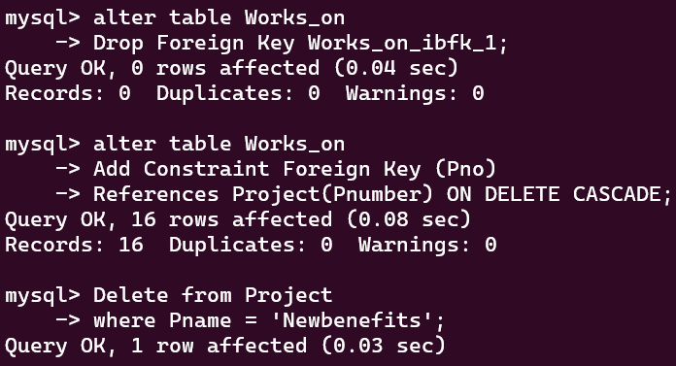

Notice that on Removing ‘Newbenefits’ Pnumber = 30, Its references from Child table Works_on also were automatically removed.
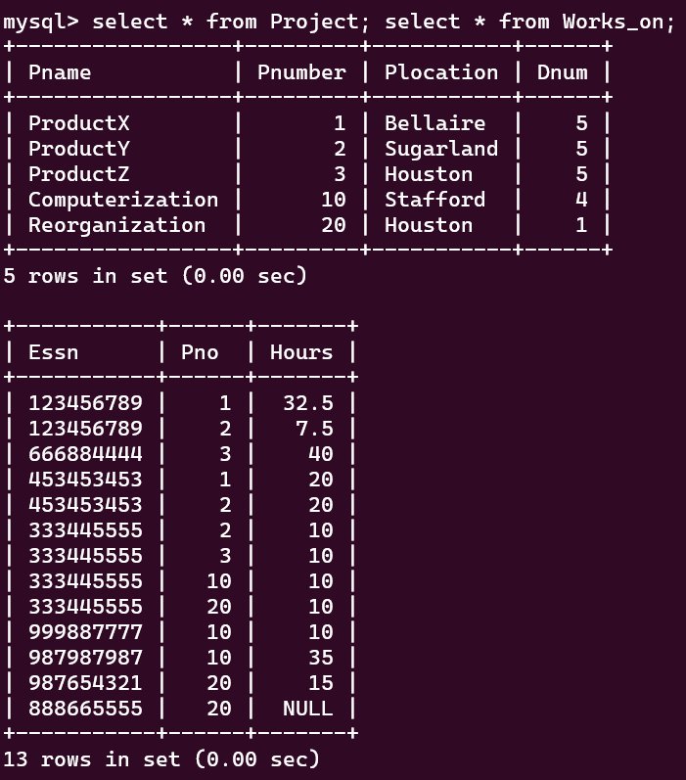

m)
